[Group Name (if you have one), Parish or diocese]
[c/o [Address of the person signing the letter – can be spiritual advisor/priest or group leader]
[address continued]

[Person you are addressing]
[Address]
[Address]

[Date]

[Salutation for a bishop: Your Excellency;]
I am writing on behalf of our Divine Will prayer and study group [name of your group if you have one] based in the [Diocese/parish of ….]. The goal of our group is, under the guidance of the Church, to read, study, and put into practice the teachings found in the writings of Servant of God Luisa Piccarreta, to provide support to our members, and to help spread the teachings to others.
In case you are unfamiliar with Servant of God Luisa Piccarreta, I include with this letter a basic introduction to Luisa and her writings, in addition to a small list of resources which I would be pleased to help you obtain upon request.
To help dispel any questions regarding the status of the Cause and writings of Servant of God Luisa Piccarreta, I include a copy of the French-language letter Dated December 3, 3024 from His Excellency, Phillippe Curbelié, Titular Archbishop of Utica and Undersecretary of the Dicastery for the Doctrine of the Faith, to His Excellency Mgr Benoit Bertrand, President of the Doctrinal Commission of the Conference of Bishops of France, in answer to his inquiry on that subject. I also include an English translation of that letter. In his response, Archbishop Curbelié states unequivocally that the Cause of Beatification of Luisa is continuing and that her writings (in the typical Italian translation) have received the Nulla Osta.
Our group’s intention in sending you this letter is to humbly request your support as we work towards becoming part of the worldwide Public Association of the Faithful, the Association of Luisa Piccarreta - Family of the Divine Will, the canonically-recognized service structure of the Association based in Luisa’s home town of Corato, Italy.
On October 11-12, 2024, at an international Divine Will retreat in Corato, Rev. Sergio Pellegrini, Vicar General of the Archdiocese of Trani, Vice-Postulator for the Cause of Servant of God Luisa Piccarreta, and Ecclesial Assistant to the Association, addressed an international group of Divine Will pilgrims representing 15 countries from five continents. In his talks, Fr. Pellegrini emphasized that unity in the Divine Will family with fidelity to the Magisterium is necessary to the advancement of Luisa’s Cause for Beatification. To foster unity and check harmful practices, groups were encouraged to form a connection with the Association of Luisa Piccarreta, and to exemplify a “decisive and evident path of ecclesiality.”
This was previously emphasized by Msgr. Paolo Rizzi, Postulator for the Cause for Beatification of Servant of God Luisa Piccarreta, on August 10, 2024, when he released a public letter in which he confirmed that the Cause of Beatification of Luisa Piccarreta was proceeding and outlined the requirements necessary for Divine Will groups worldwide to obtain affiliation with the Family of the Divine Will. In short, he states:
“While objectively recognizing that so many Divine Will Groups have implemented in this direction a decisive and evident path of ecclesiality, it is indispensable and incumbent on those who have not yet done so to strive ‘to anchor the reading of these writings in the doctrine of the Church and in a dignified conduct of life, making a balanced and respectful missionary proclamation spring from the doctrine of the Divine Will, a proclamation which has been harmoniously inserted into the pastoral activity of the local Churches’ (quoting Msgr. Leonardo D'Ascenzo, Archbishop of Trani-Barletta Bisceglie, Communication No. 4 regarding the Servant of God Luisa Piccarreta, March 4, 2020).
“With this in mind, it seems most appropriate for bishops to recognize and admit into their ecclesiastical circumscriptions only those Divine Will Groups that meet the aforementioned requirements. After their bishop's approval, these groups can obtain the affiliation to the Family of the Divine Will, which was established by the Public Association of the Faithful "Luisa Piccarreta-P.F.D.V. " of Corato, a service structure under the supervision of the pro-tempore Archbishop of Trani-Barletta-Bisceglie, whose ecclesial figure the Dicastery for the Causes of Saints has always indicated as the official reference for those who follow the spirituality and message of the Servant of God Luisa Piccarreta throughout the world.”
Therefore, it is the desire of the members of our group 1) to live and promote the writings of Servant of God Luisa Piccarreta on a decisive and evident path of ecclesiality in union with our local bishop, 2) to form an association with the worldwide Family of the Divine Will under their statutes and bylaws, and 3) to form connections with other groups in the international Family of the Divine Will, and 4) to further the mission of the Divine Will with the Association for the glory of God and the glorification of Servant of God Luisa Piccarreta.
Thank you for considering our request to have our Divine Will group [name, parish] admitted into the ecclesiastical circumscriptions of the diocese as recommended by Msgr. Rizzi in his letter.

Respectfully yours in Christ,
[signature if printed and mailed, otherwise delete]
[your name, title in the group if you have one]
[phone]
[email]

Servant of God Luisa Piccarreta
Brief biography
Luisa Piccarreta (1865-1947) was a humble, saintly soul who lived most of her life in or near Corato, Italy, where her home is now preserved as a shrine. After receiving her First Communion, she began to have visions and to hear the Lord speaking to her. For the rest of her 82 years of life, Luisa often experienced ecstasies, which she referred to as her “usual state,” in which Jesus gradually revealed to her his plan for this stage of salvation history.
While in her “usual state”, her physical body was left unable to move or even be moved until a priest came to bless her. This was the means Jesus used to involve the Church in the mission of Luisa. From the very beginning Jesus made it clear that priests were essential to the mission.
At the age of 16, Luisa accepted the state of victimhood, which led to her remaining confined to her bed for the last 60+ years of her life. During most of her life, Luisa existed on the Eucharist alone, only taking food out of obedience to her confessor, but usually bringing it up again right away. Like Jesus, Luisa’s food was to do the Will of the Father.
As her life and mission progressed, Luisa’s holiness was recognized by many, including (now Saint) Rev. Annibale di Francia (censor of her writings), (now Saint) Rev. Padre Pio, and the many other priests and bishops who knew her well. Pope Leo XIII himself gave permission for the priests to celebrate Mass in her bedroom.
Luisa died on March 4, 1947 at the age of 82 after a short bout of pneumonia, the only diagnosable illness of her life. In 1963, Luisa’s mortal remains were moved to the Church of Santa Maria Greca in Corato, Italy. Luisa’s Cause for Beatification and Canonization was opened in 1994 and the diocesan phase was concluded in 2005.
In 2015, the Vatican Press published Luisa’s biography, Sun of My Will, written by Maria Rosario del Genio, with Preface by Cardinal José Saraiva Martins and Afterword by Archbishop Giovan Battista Picchierri.
In 2018 the Vatican gave permission to move the body of Luisa from the side of Santa Maria Greca Church to the front of the Church at the side Altar of the Holy Spirit. This was a great sign that the Vatican recognized her heroic sanctity.
The Writings of Luisa
Out of obedience to her confessors, Luisa reluctantly spent almost 40 years recording her spiritual experiences. Though she barely had a first-grade education, she wrote over 8,000 pages of deeply theological teachings in 36 notebooks commonly known as the Volumes. Jesus himself titled the work: The Book of Heaven: The Call of the Creature to the Order, the Place and the Purpose for which He Was Created by God.
Luisa also recorded other important works which have the Imprimatur/Nihil Obstat such as The Twenty-Four Hours of the Passion of Our Lord Jesus Christ and The Virgin Mary in the Kingdom of the Divine Will. Her personal letters and childhood memoirs are also included in the body of her available writings, which total some 15,000 pages.
(Now saint) Rev. Annibale di Francia, founder of two religious orders, and editor and censor of Luisa’s writings, gave his Nihil Obstat to the first 19 Volumes, the only ones written in his lifetime, as well as to some of her other writings. Archbishop Joseph Leo followed with his Imprimatur.
In 2004, Annibale di Francia was canonized by Pope John Paul II, and in 2010 Pope Benedict XVI installed a large statue of the saint outside the Vatican Basilica.
In 2018 an Italian-language Typical Edition of the Writings of Servant of God Luisa Piccarreta was completed and submitted to the Vatican. While there is yet no official English translation, groups and individuals are permitted and encouraged to study unofficial translations of the writings but are to do so in light of Church teaching with fidelity to the Magisterium.
The Current Status of the Cause of Servant of God Luisa Piccarreta
In June 2024, the Dicastery for the Doctrine of Faith announced that Luisa’s cause for beatification was proceeding, and with their Nihil Obstat confirmed that her writings (in the official Italian translation) contained no doctrinal errors, although there were ambiguities that needed to be reviewed and clarified.
This was confirmed by the Dicastery for the Doctrine of the Faith in December 2024 when His Excellency, Phillippe Curbelié, Under-Secretary of the Dicastery for the Doctrine of the Faith, responded to His Excellency, Mgr Benoit Bertrand, President of the Doctrinal Commission of the Conference of Bishops of France, who had requested official clarifications regarding the writings of Servant of God Luisa Piccarreta. His response was very positive. The French-language original on Dicastery letterhead is included in this package along with an English translation of the text.
Divine Will Cenacles and Prayer Groups
As of the time of this writing, two religious orders have been formed under the Rule of St. Benedict, dedicated to Eucharistic Adoration and study of the Divine Will teachings: The Benedictine Daughters of Divine Will (https://benedictinesofdivinewill.org) and The Benedictine Monks of Divine Will (https://osbdv.com). A Third Order has also been formed, The Benedictine Oblates of the Divine Will.
Today there are many dozens of Divine Will groups all over the world studying and living the writings of Servant of God Luisa Piccarreta. They are being encouraged to seek their bishop’s approval and to obtain affiliation with the Family of the Divine Will, which was established by the Public Association of the Faithful ‘Luisa Piccarreta-P.F.D.V.’ of Corato [Italy], a service structure under the supervision of the pro-tempore Archbishop of Trani-Barletta-Bisceglie.
Basic Doctrine
(NOTE: This is by no means a comprehensive summary of the thousands of pages penned by Luisa. It is a mere sip from the boundless font communicated by Jesus to his chosen soul, Luisa Piccarreta.)
The Gift of Living in the Divine Will
It is important to understand that “living in” the Divine Will is not the same as “doing” the Divine Will. Jesus tells Luisa that the Gift of Living in his Divine Will is not so much a call to personal sanctity, as it is a call to sanctify all things for the fulfillment of God’s kingdom. We continue to do all our good and holy
practices but learn, as Jesus taught us through Luisa, to do them in the Divine Will, by grace, for the glory of God and the good of all.
The Three Fiats: Creation, Redemption and Sanctification
[Jesus to Luisa:] "My daughter, the first Fiat [‘Let it be done’] was pronounced in Creation with no intervention of creature. The second Fiat was pronounced in Redemption; I wanted the intervention of the creature, and I chose my Mother for the completion of the second Fiat. Now, for the fulfillment of both, I want to pronounce the third Fiat, and I want to pronounce It through you [Luisa]…” (L. Piccarreta, Book of Heaven, Volume 12, January 24, 1921)
Jesus tells Luisa that the Holy Spirit is ready to descend in his fullness on the earth, to pronounce the Fiat of Sanctification. It is the time of the fulfillment of the only prayer Jesus taught us and which the Church has been praying for 2000 years: Thy kingdom come, thy will be done on earth as it is in heaven.
[Jesus to Luisa:] "Every two thousand years I have renewed the world. In the first two thousand years I renewed it with the Deluge [Flood]; in the second two thousand I renewed it with my coming upon earth when I manifested my Humanity...Now we are around the third two thousand years, and there will be a third renewal. This is the reason for the general confusion: it is nothing other than the preparation of the third renewal.” (L. Piccarreta, Book of Heaven, Volume 12, January 29, 1919)
Through Luisa, we learn that God is calling us to be partners, by grace, in bringing about this third renewal through the Gift of Living in the Divine Will. It is not the end of the world, but the end of an era, a call to return to the Order, the Place and the Purpose, for which we were created, where God’s will shall be done on earth as it is in heaven. It is the long-awaited era of peace foretold by Our Lady, a Sabbath rest as we await the blessed hope and the coming of our Savior, Jesus Christ.
Fiat.

January 2025

Resources
The Association

- DECREE AND STATUTE OF THE ASSOCIATION OF LUISA PICCARRETA (2010)
https://en.luisapiccarretaofficial.org/decree-statute
- BYLAWS OF THE SERVICE STRUCTURE “FAMILY OF THE DIVINE WILL” (2019)
https://en.luisapiccarretaofficial.org/cause-news/regulations-of-the-service-structure-named-family-of-the-divine-will/66

Further Reading (More resources available upon request)

- The Sun of My Will: Luisa Piccarreta, An Ordinary Life Outside the Ordinary (official biography)
by Maria Rosaria del Genio
  - https://www.vaticanum.com/en/the-sun-of-my-will-luisa-piccarreta-an-ordinary-life-outside-the-ordinary-maria-rosaria-del-genio or
  - https://stanthonyshop.com/search
- The Twenty-Four Hours of the Passion of Our Lord Jesus Christ (with Imprimaturs)
by the Servant of God, Luisa Piccarreta
  - PDF: https://divinewill.org/wp-content/uploads/2014/03/Hours_Book_Rev-12_11_10-Summer_2009_8.5-x-11_format-Rev-5_4_13use.pdf
  - Book: https://www.blancpublishing.com/public-catalog.html
- The Virgin Mary in the Kingdom of the Divine Will (with Imprimatur)
by the Servant of God, Luisa Piccarreta
  - PDF: https://bookofheaven.com/wp-content/uploads/2023/04/BVM-in-the-Divine-Will-2023.pdf
  - Book: https://www.blancpublishing.com/public-catalog.html

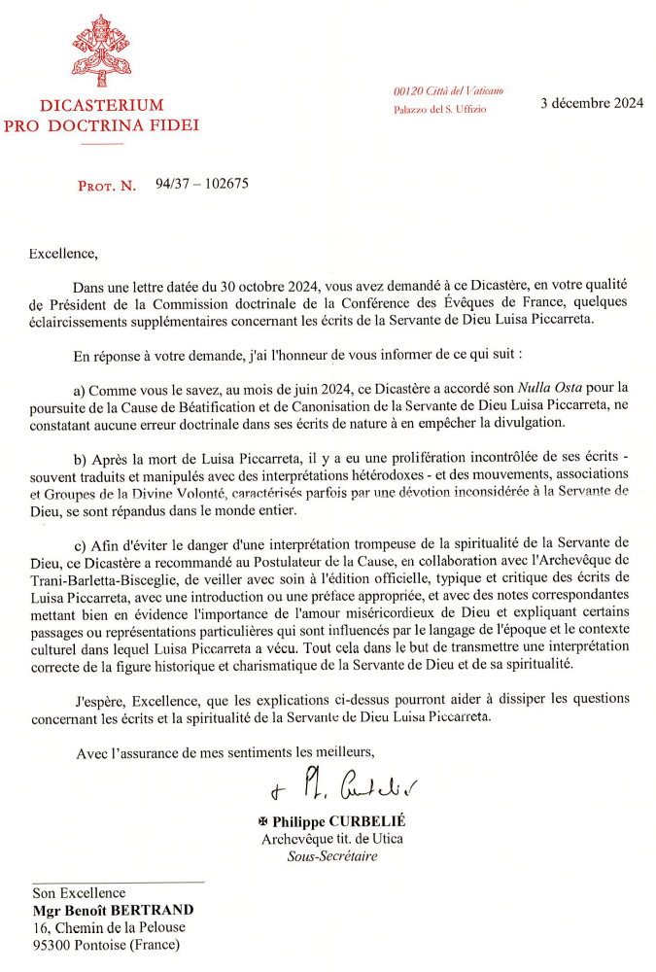
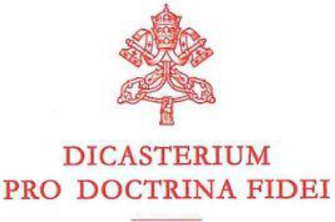
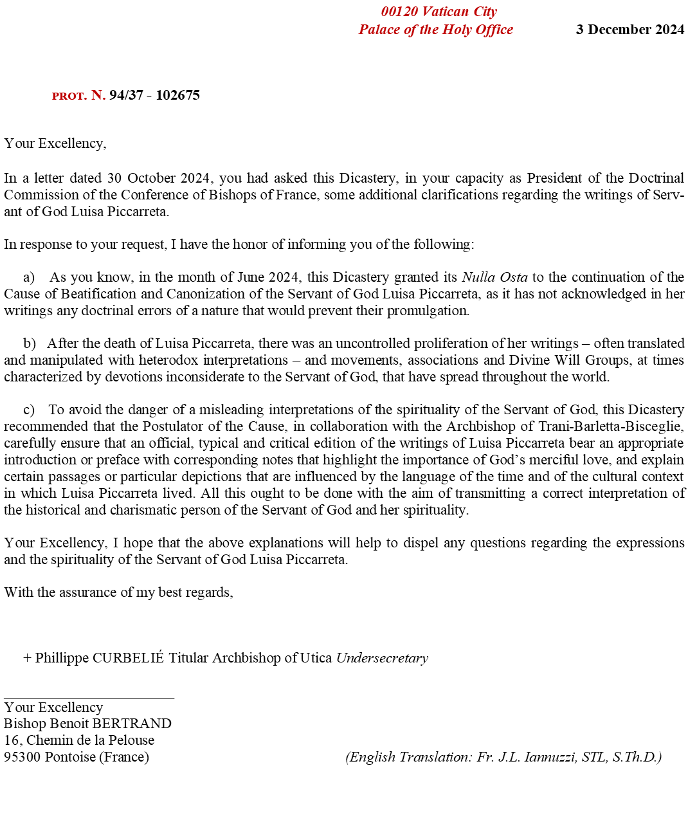

https://en.luisapiccarretaofficial.org/cause-news/communication-of-the-postulator-msgr-paolo-rizzi-about-the-cause-of-beatification/80

